**IN3005**

**Interim Coursework Report**

**Tayyab Hussain**

**Task 1:**

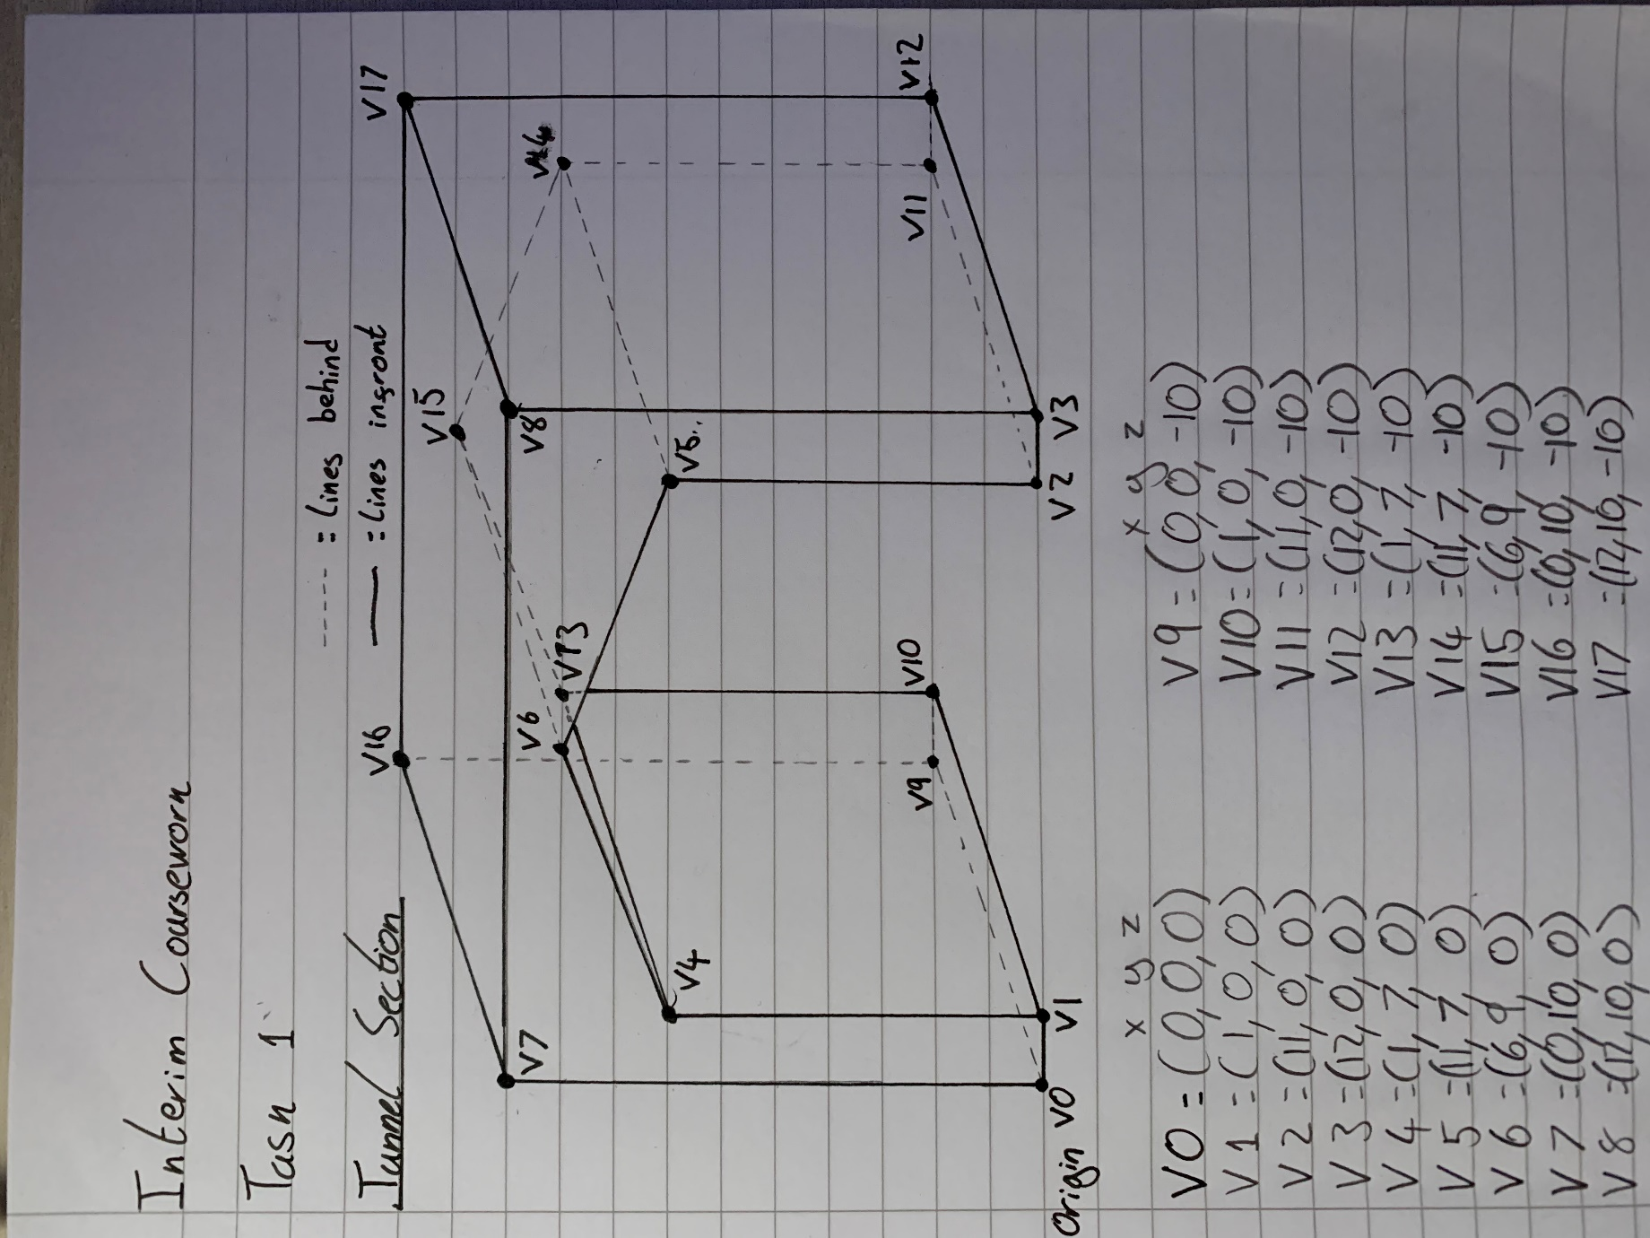

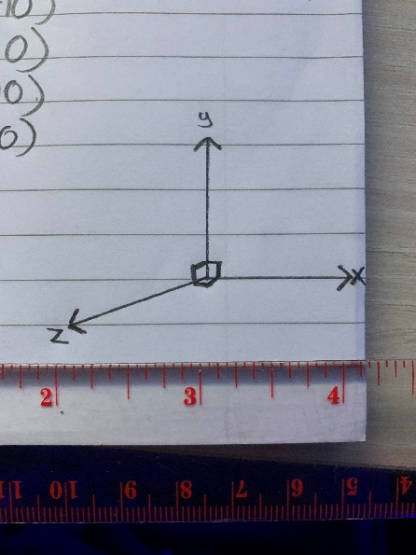

Vertex Coordinates = (x,y,z)

|  |  |
| --- | --- |
| V0 = (0,0,0) | V9 = (0,0,-10) |
| V1 = (1,0,0) | V10 = (1,0,-10) |
| V2 = (11,0,0) | V11 = (11,0,-10) |
| V3 = (12,0,0) | V12 = (12,0,-10) |
| V4 = (1,7,0) | V13 = (1,7,-10) |
| V5 = (11,7,0) | V14 = (11,7,-10) |
| V6 = (6,9,0) | V15 = (6,9,-10) |
| V7 = (0,10,0) | V16 = (0,10,-10) |
| V8 = (12,10,0) | V17 = (12,10,-10) |

The **origin** is at the bottom left corner of the object, at vertex VO. I have chosen this to be the origin as it is at ground level and the front outermost edge of the object, making it easier to place the object in the scene.

**Normal Vectors, Texture Coordinates and Triangle Lists:**

The screenshots on the left are of the normal vectors for every face. The screenshots on the right are the texture coordinates for that face and the triangles that make up that face with the correct winding.

To work out the normal for every face, I took a small triangle from every face such as the one shown below with the vertices, V0, V1 and V7. I then calculated 2 vectors from this triangle, called p and q. Working out the cross-product for these vectors and normalising the result gave me the normal vector for each face.

For the texture coordinates, I treated every face as a square. I then worked out where each point would be in the 2d plane between 0 and 1. For example, V6 in the figure below is halfway across the face and 9/10ths of the way up so the texture coordinates would be (0.5, 0.9)

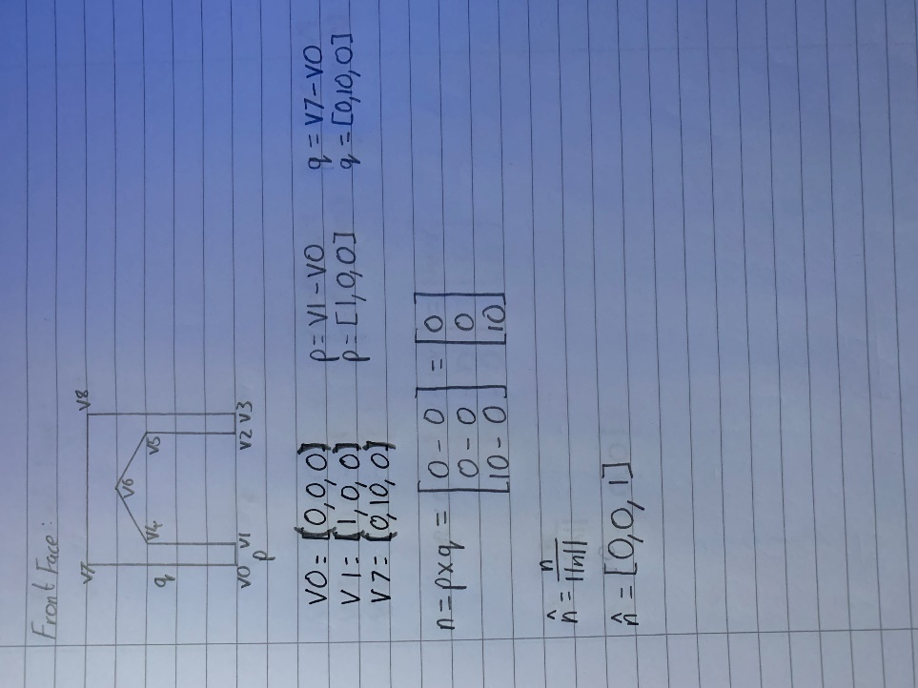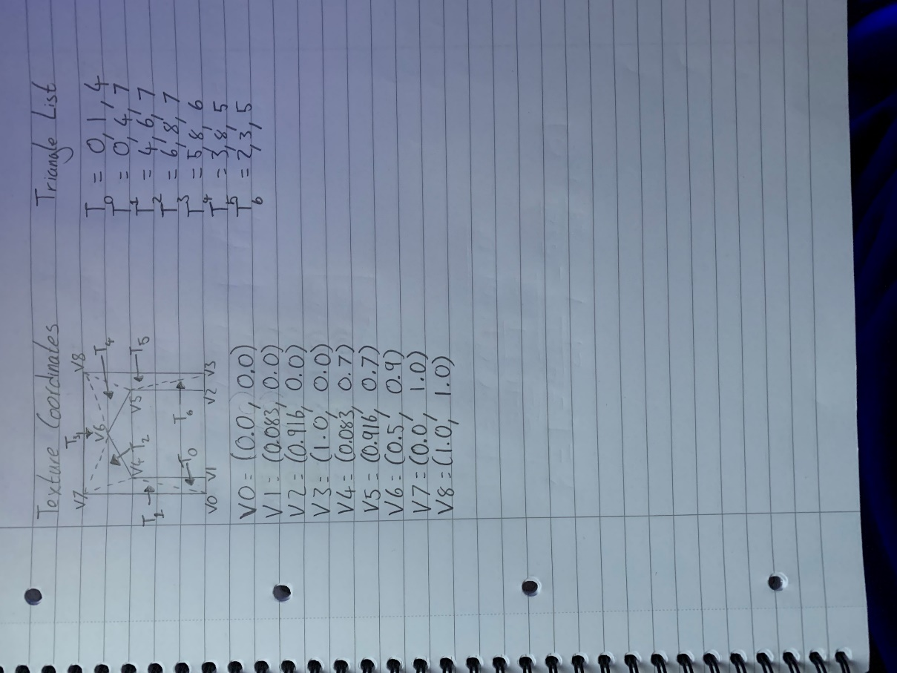

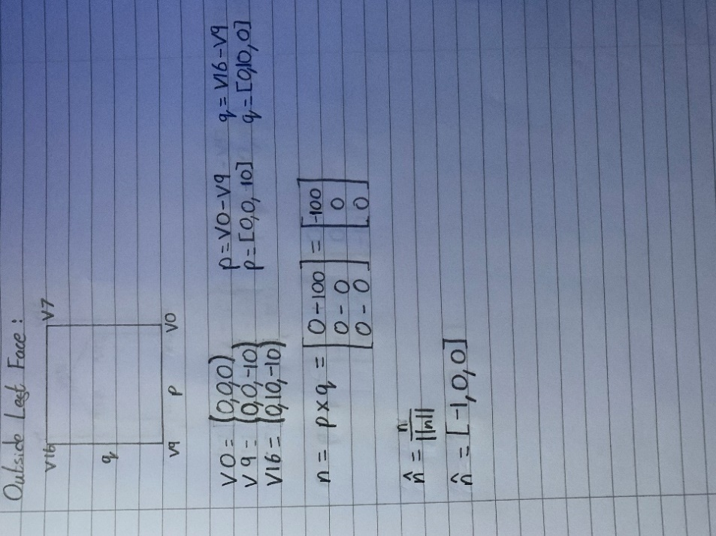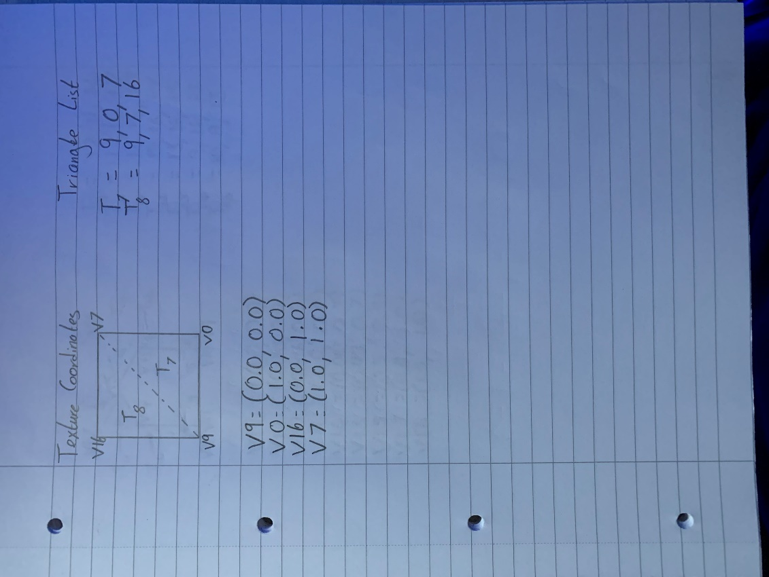

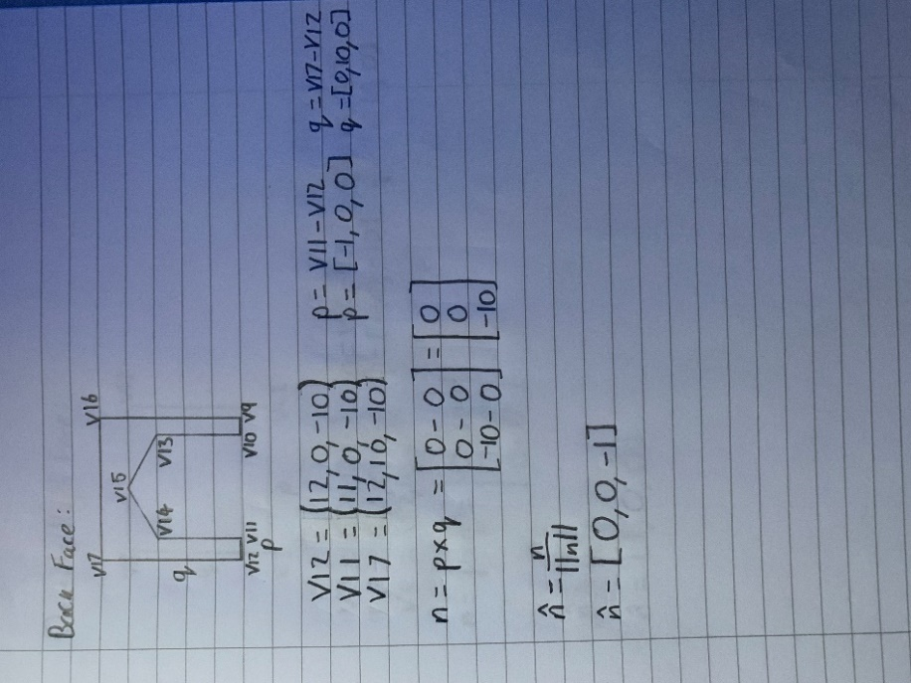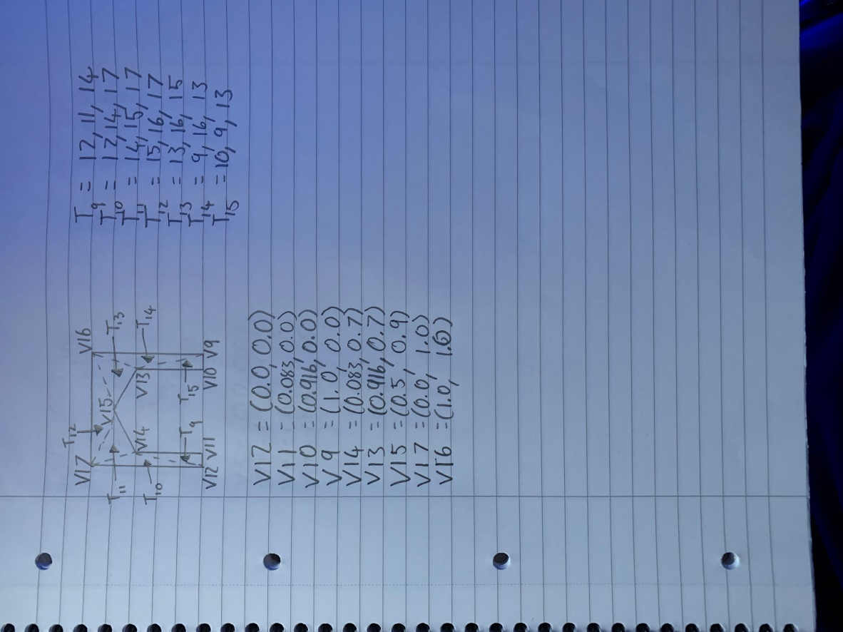

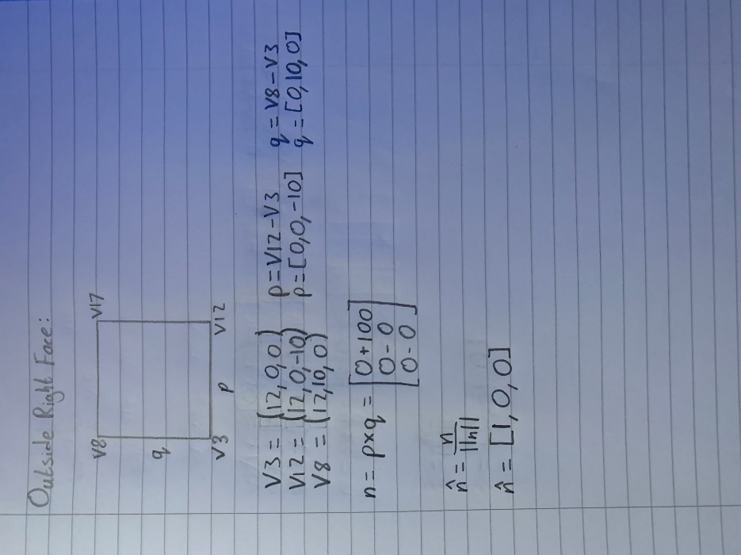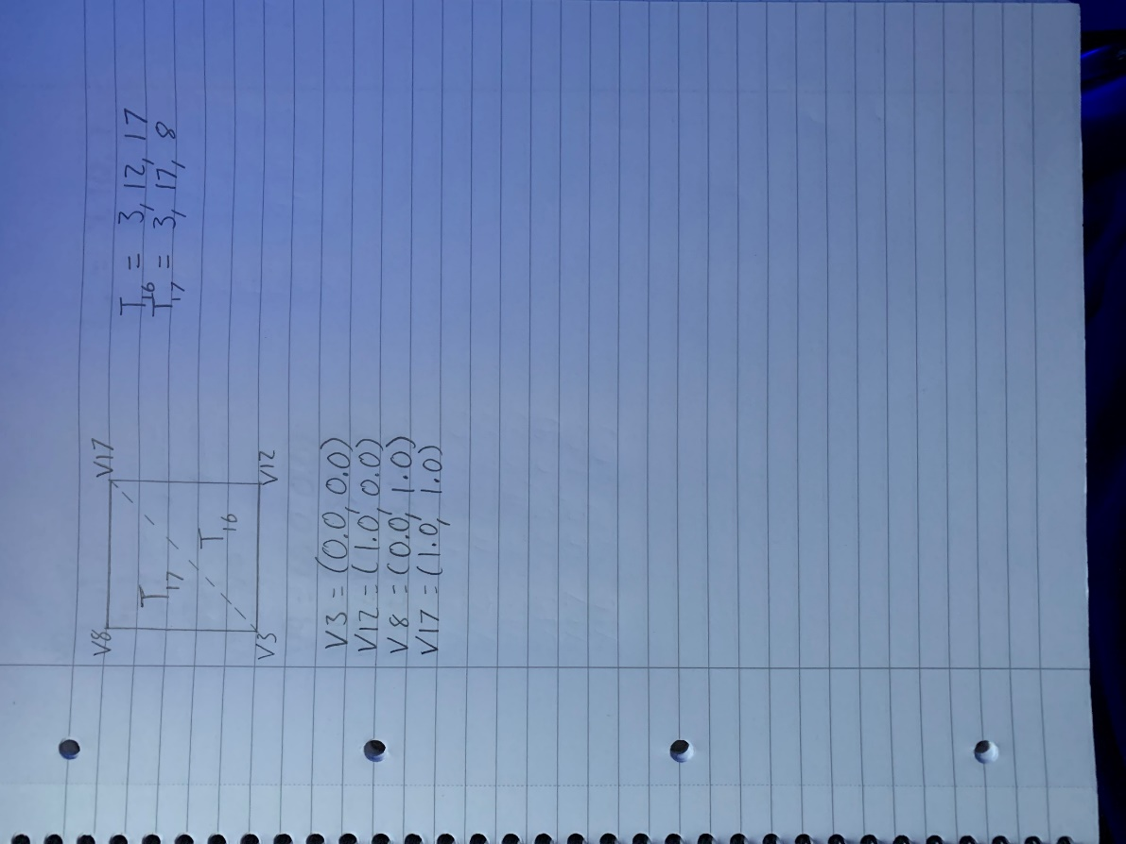

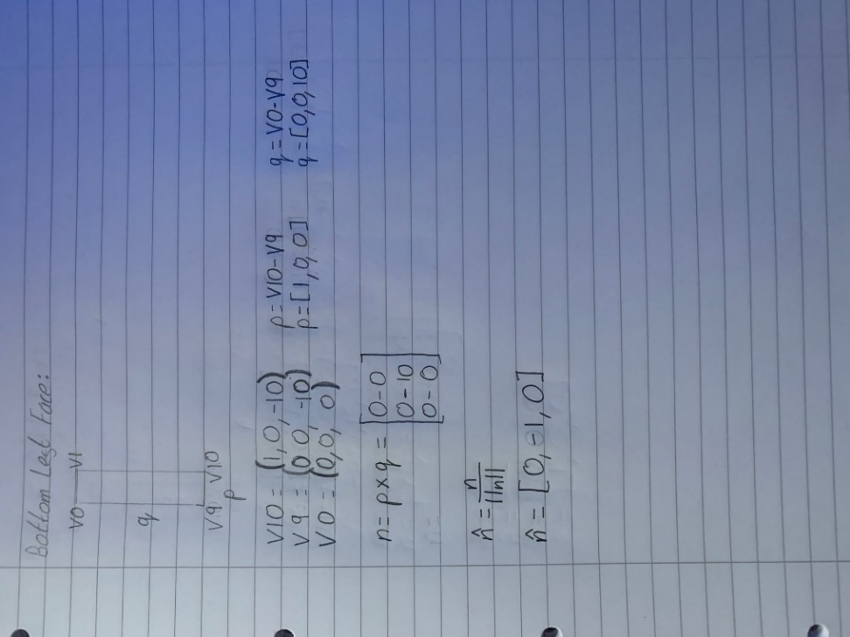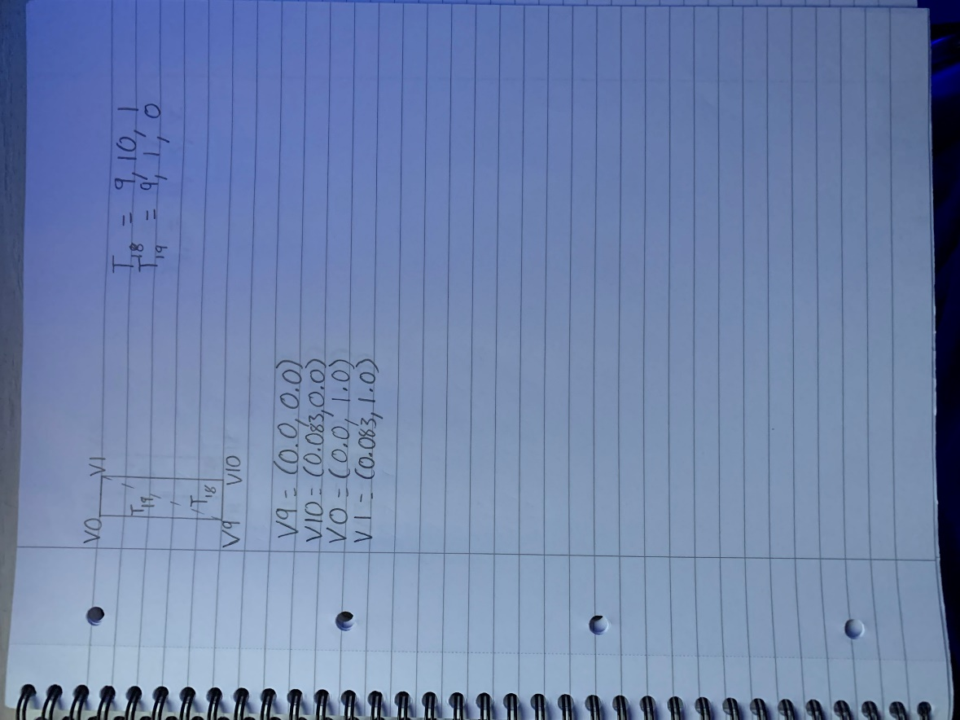

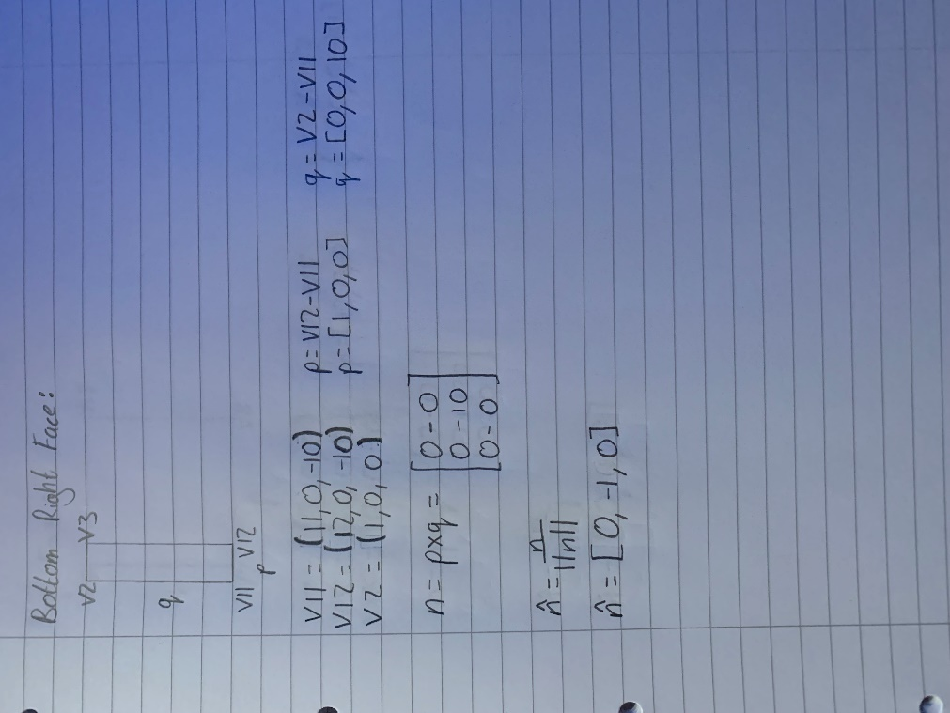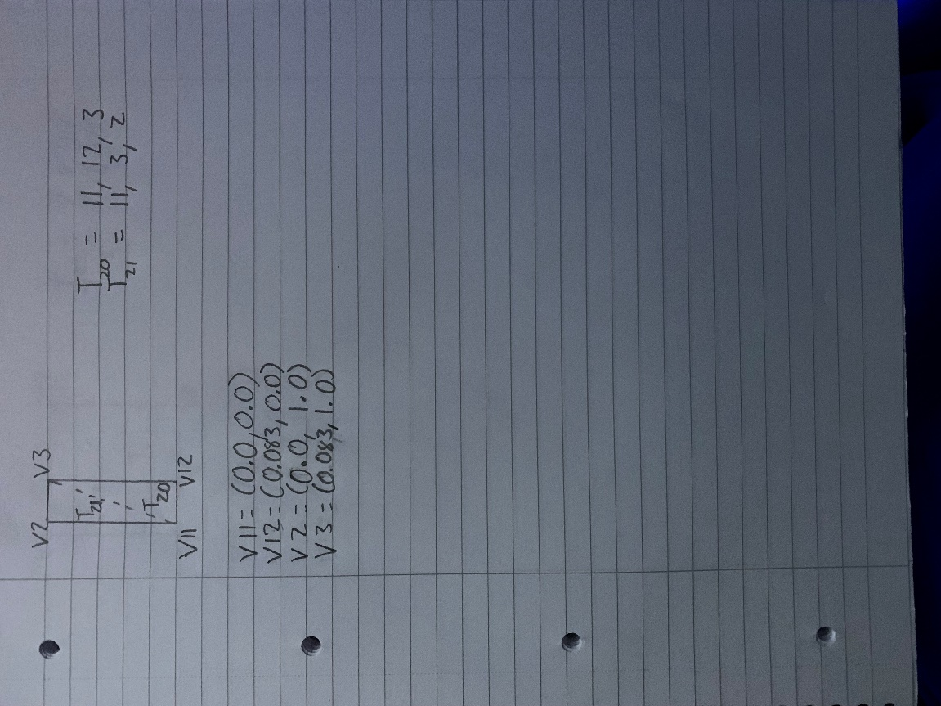

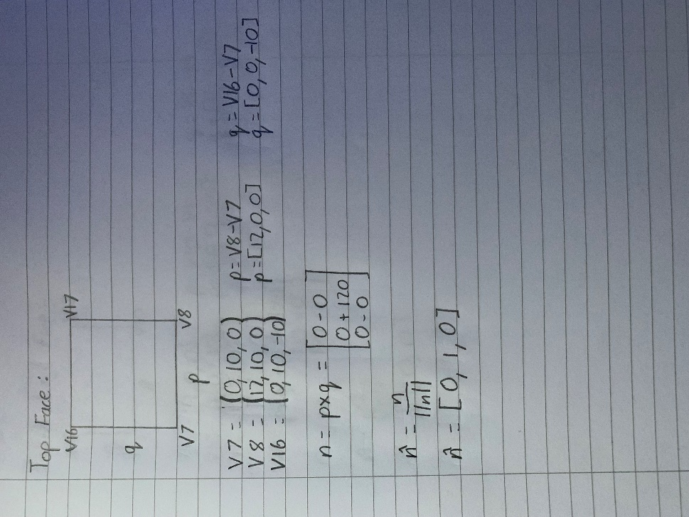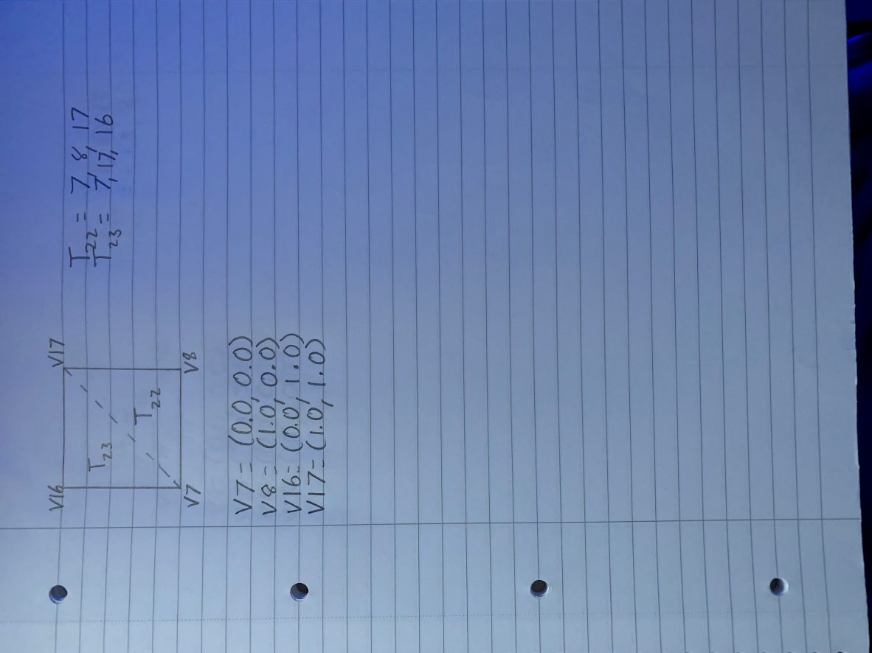

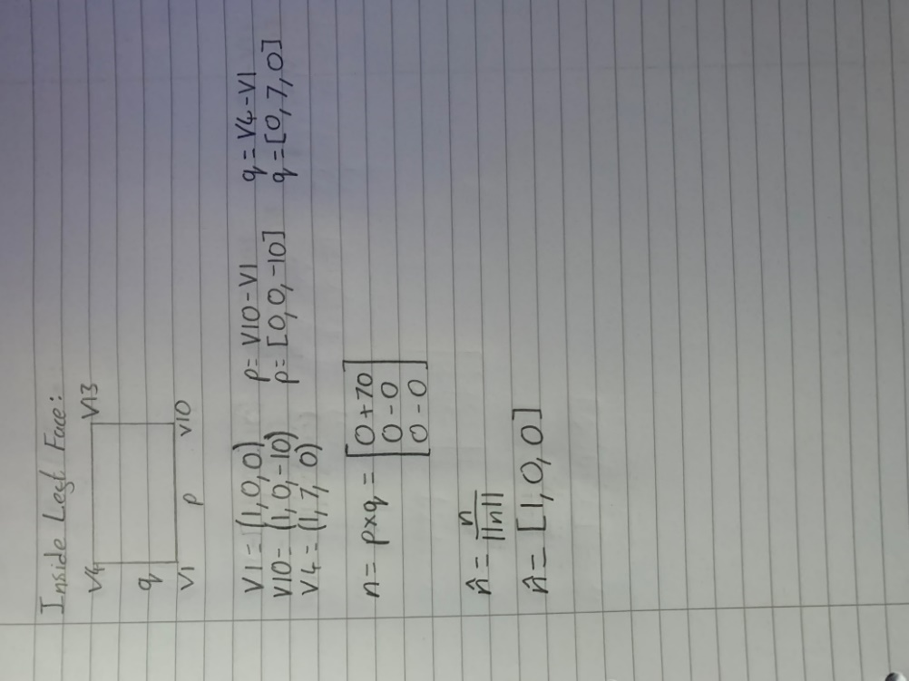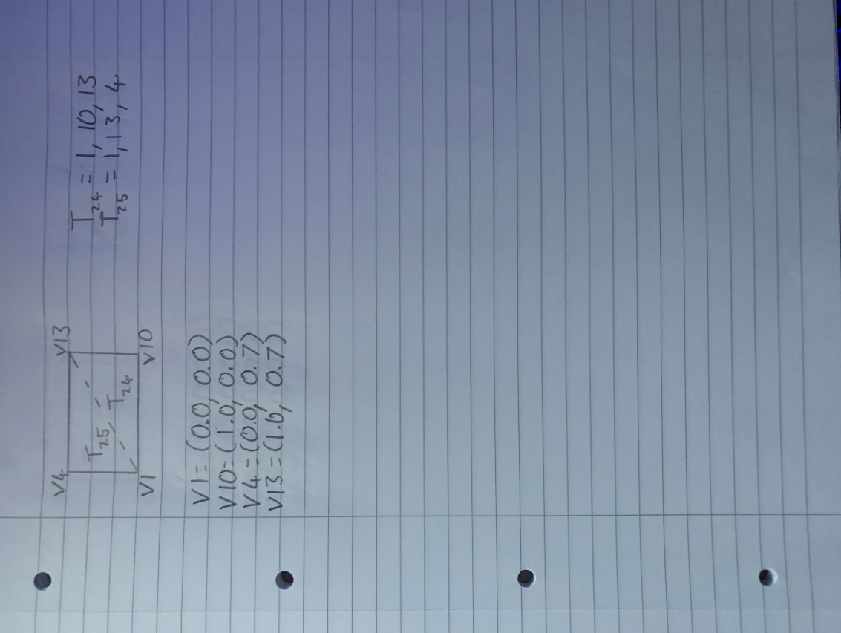

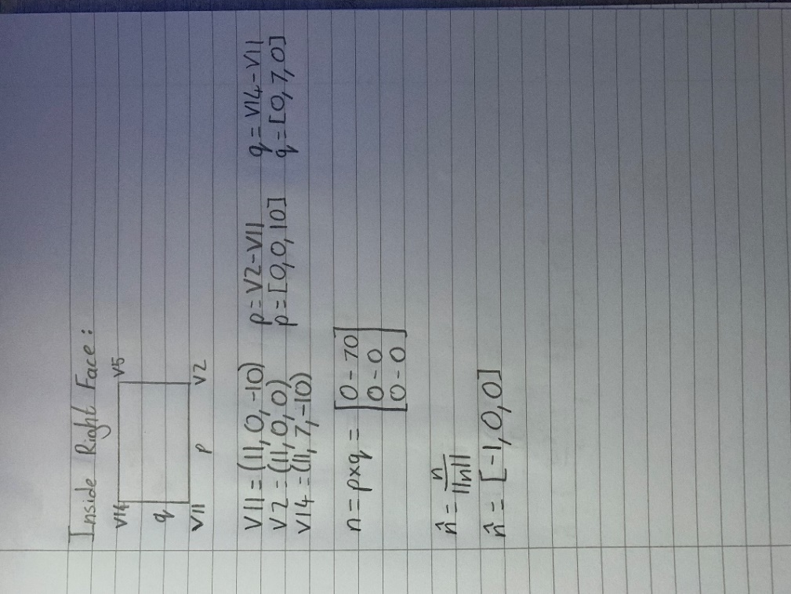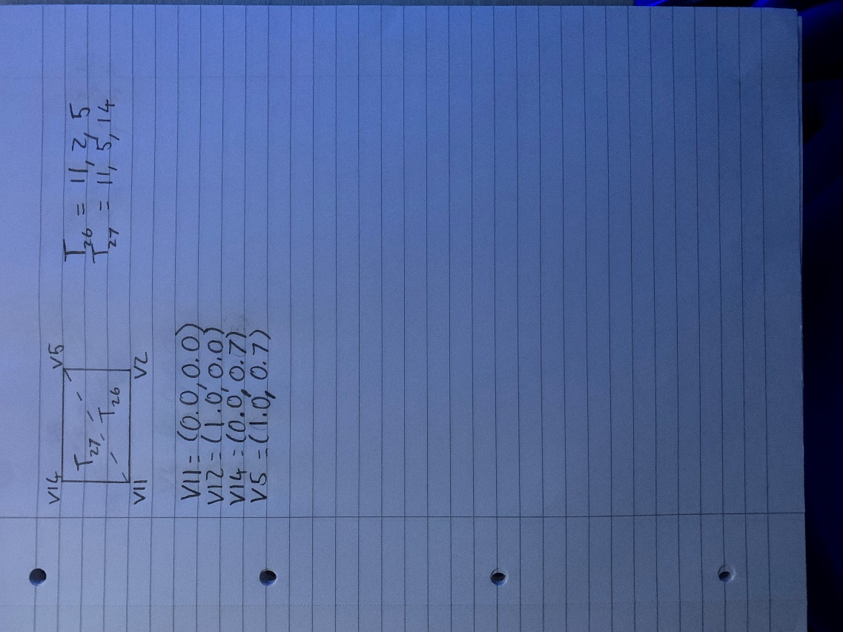

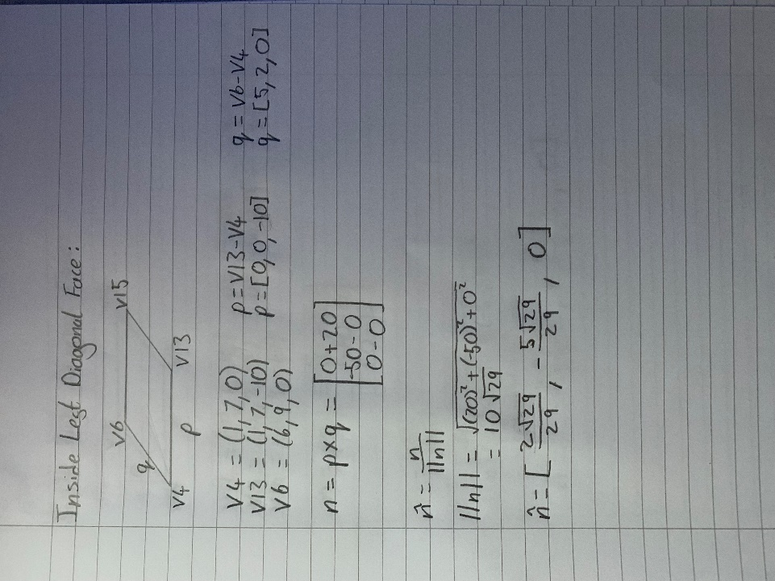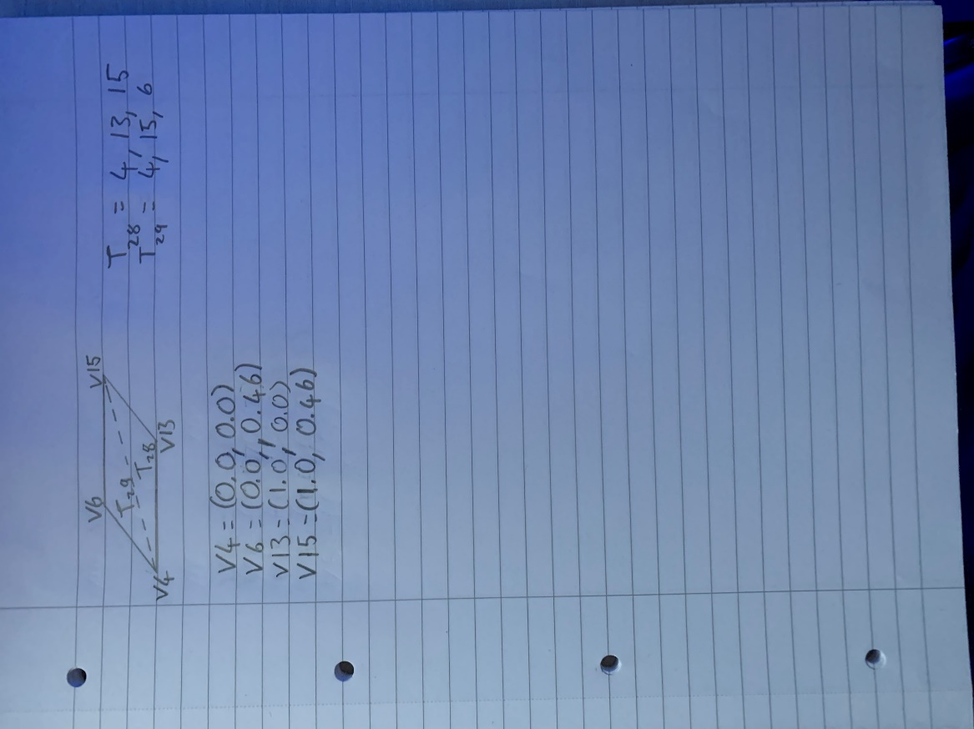

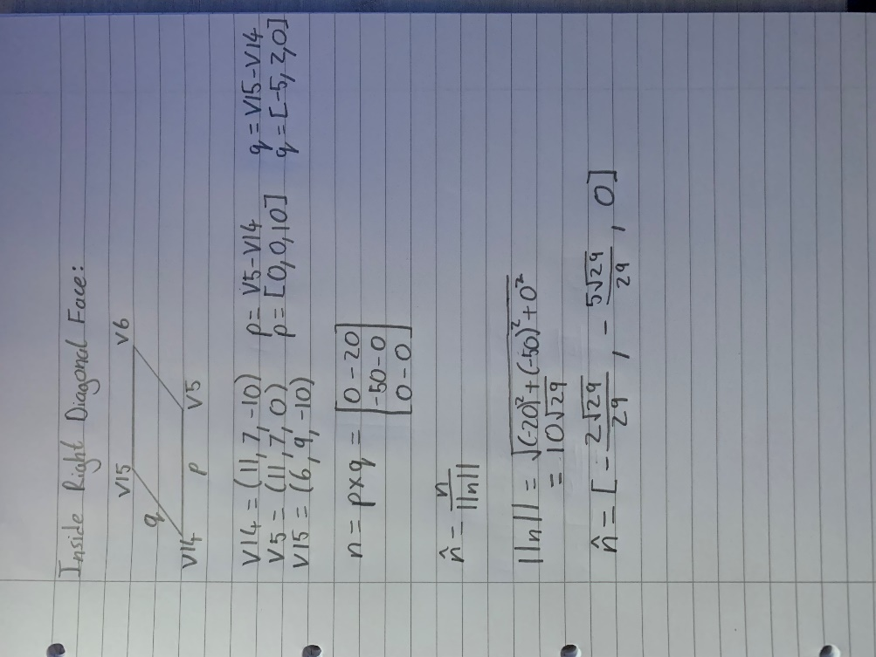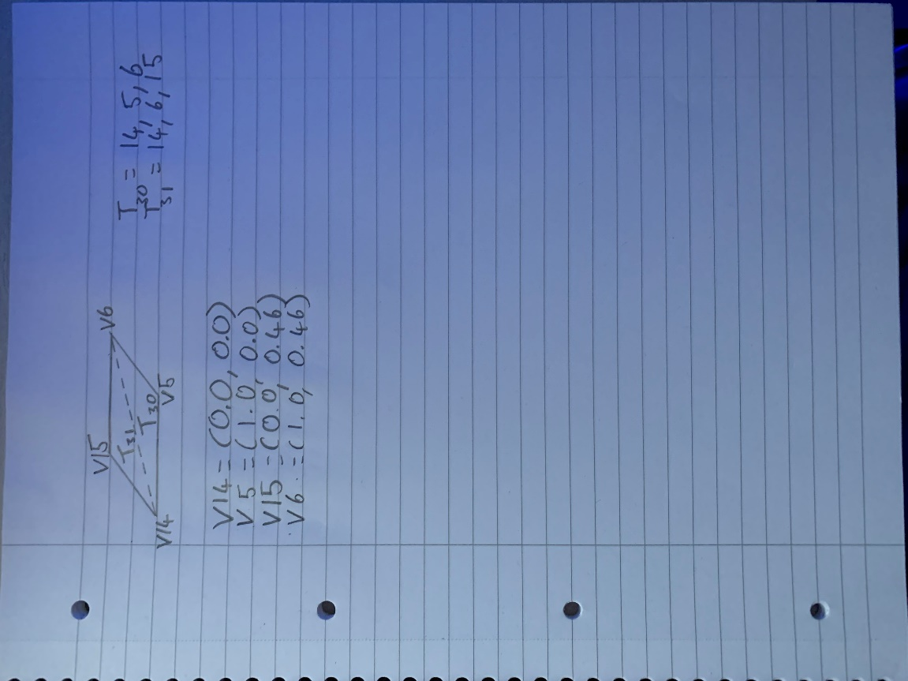

**Task 2:**

I am going to use an interleaved layout for my VBO. This will consist of the vertex position (x, y, z), texture coordinate (s, t), normal vector (xn, yn, zn) and colour (r, g, b). 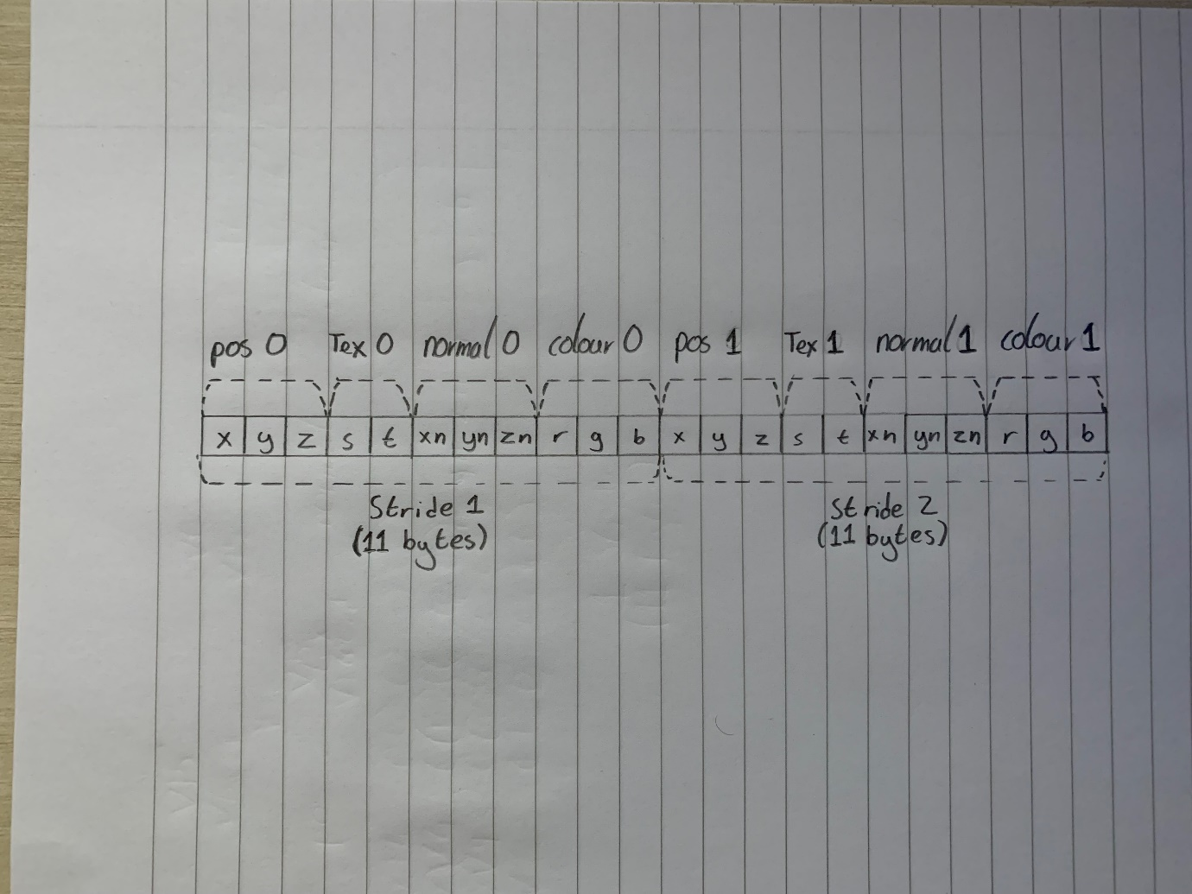

To upload the data to the GPU the following calls to OpenGL are used:

// Upload data to GPU

m_VBO.UploadDataToGPU(GL_STATIC_DRAW);

GLsizei stride = 3*sizeof(glm::vec3)+sizeof(glm::vec2);

// Vertex positions

glEnableVertexAttribArray(0);

glVertexAttribPointer(0, 3, GL_FLOAT, GL_FALSE, stride, 0);

// Texture coordinates

glEnableVertexAttribArray(1);

glVertexAttribPointer(1, 2, GL_FLOAT, GL_FALSE, stride, (void*)sizeof(glm::vec3));

// Normal vectors

glEnableVertexAttribArray(2);

glVertexAttribPointer(2, 3, GL_FLOAT, GL_FALSE, stride, (void*)(sizeof(glm::vec3)+sizeof(glm::vec2)));

// Colours

glEnableVertexAttribArray(3);

glVertexAttribPointer(3, 3, GL_FLOAT, GL_FALSE, stride, (void*)(sizeof(glm::vec3) + sizeof(glm::vec2) + sizeof(glm::vec3)));

**Task 3:**

After completing task 3, this is what my object looks like:

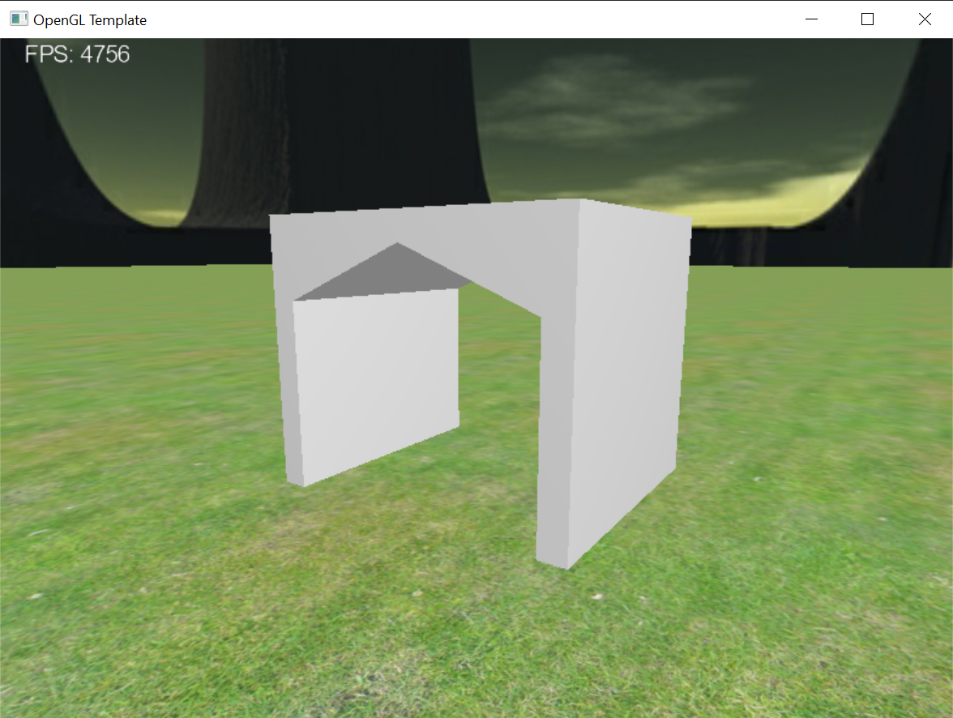

**Task 4:**

I need 2 shaders to render my object, the fragment shader and the vertex shader.

This is the main GLSL code listing for the vertex shader that will send information about the vertexes to the fragment shader.

// This is the entry point into the vertex shader

void main()

{

// Transform the vertex spatial position using

gl_Position = matrices.projMatrix * matrices.modelViewMatrix * vec4(inPosition, 1.0f);

// Get the vertex normal and vertex position in eye coordinates

vec3 vEyeNorm = normalize(matrices.normalMatrix * inNormal);

vec4 vEyePosition = matrices.modelViewMatrix * vec4(inPosition, 1.0f);

// Apply the Phong model to compute the vertex colour

//vColour = PhongModel(vEyePosition, vEyeNorm);

vColour = inColour;

// Pass through the texture coordinate

vTexCoord = inCoord;

}

/////////////////////////////////////////////////////////////////////////////////

This is the GLSL code listing for the fragment shader.

in vec3 vColour; // Interpolated colour using colour calculated in the vertex shader

in vec2 vTexCoord; // Interpolated texture coordinate using texture coordinate from the vertex shader

out vec4 vOutputColour; // The output colour

uniform sampler2D sampler0; // The texture sampler

uniform bool bUseTexture; // A flag indicating if texture-mapping should be applied

void main()

{

// Get the texel colour from the texture sampler

vec4 vTexColour = texture(sampler0, vTexCoord);

if (bUseTexture)

vOutputColour = vTexColour*vec4(vColour, 1.0f); // Combine object colour and texture

else

vOutputColour = vec4(vColour, 1.0f); // Just use the colour instead

}

This is what my object currently looks like with this shader program.

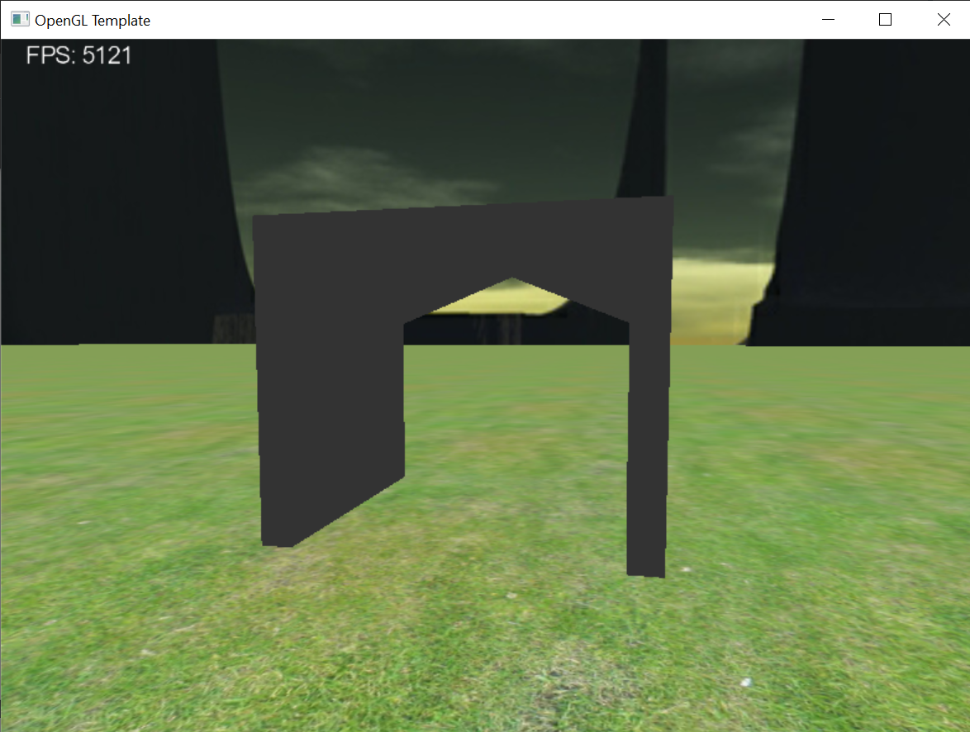

As you can see, the object is not properly lit and therefore looks very flat. I will use the Phong model along with each vertex colour to make my object look more visually appealing. The code for the Phong model requires some additional information from the client program about the light and object shininess. This is provided from the client side like this:

// Set light and materials in tunnel shader program

pTunnelProgram->SetUniform("light1.position", viewMatrix * lightPosition1); // Position of light source *in eye coordinates*

pTunnelProgram->SetUniform("light1.La", glm::vec3(1, 1, 1)); // Ambient colour of light

pTunnelProgram->SetUniform("light1.Ld", glm::vec3(1, 1, 1)); // Diffuse colour of light

pTunnelProgram->SetUniform("light1.Ls", glm::vec3(1, 1, 1)); // Specular colour of light

pTunnelProgram->SetUniform("material1.shininess", 15.0f); // Shininess material property

This code sets the light position, the light ambient colour, the diffuse colour and the specular colour. It also sets the object’s shininess.

The Phong model and the vertex shader in general require information from my VBO to allow it to render each vertex. I have passed through the VBO details to the vertex shader like this:

// Layout of vertex attributes in VBO

layout (location = 0) in vec3 inPosition;

layout (location = 1) in vec2 inCoord;

layout (location = 2) in vec3 inNormal;

layout (location = 3) in vec3 inColour;

I also intend to use a texture for my object later. In order to do this, I have included some code within the client program to tell the shaders if a texture is being used and to provide the shader with a texture sampler if there is a texture being used. I have also used uniform variables to receive this information within the fragment shader like this:

uniform sampler2D sampler0; // The texture sampler

uniform bool bUseTexture; // A flag indicating if texture-mapping should be applied

The fragment shader`s main function already has the functionality to account for this. It creates a colour by multiplying the colour from the texture by the vertex colour specified by the VBO about the object.

My object now looks like this:

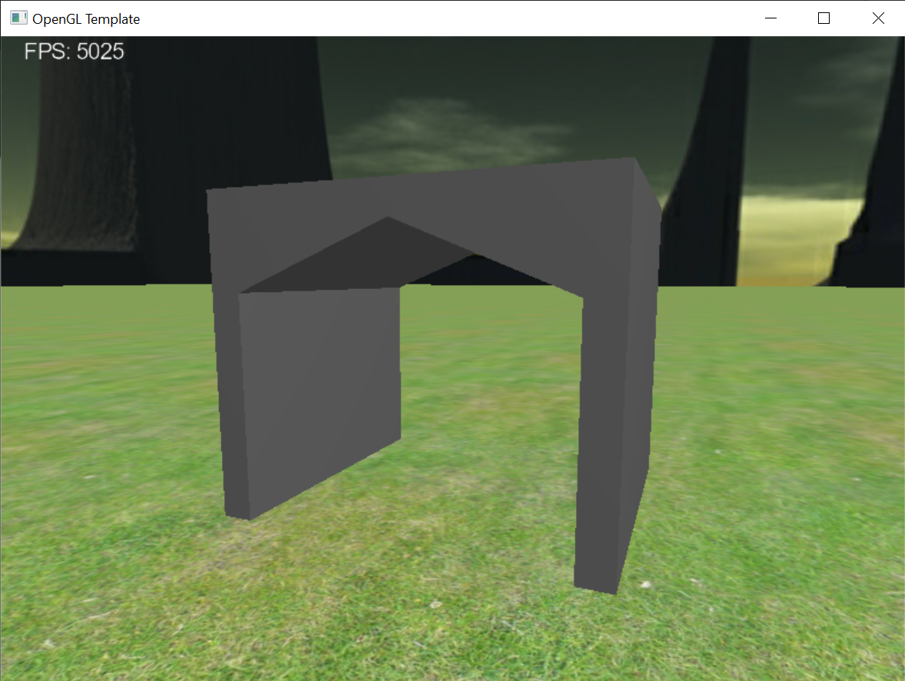

**Task 5:**

fovy is used to control how much of the gameworld is squeezed into the viewing frustum in the y direction. A higher FOV value allows for the camera to see more in the world but it also makes the object appear further from the camera.

The aspect ratio defines the proportion between the width and the height of the viewing frustum. A smaller aspect ratio such as 1:1 would make the viewing frustum square, whereas a larger aspect ratio like 16:9 would allow for a more rectangular view of the game. It is generally best to keep the aspect ratio the same as the size of your game window.

zNear and zFar set the near and far clipping plane of the viewing frustum respectively. What this means is the game will only show the parts of the gameworld that lie between the zNear and zFar values.

To get the camera to rotate around the object and always face the object I first created a catmullRom spline to render a small circular path around the object for the camera to follow. I centred the path around 0,0,0 and placed my object slightly offset centre by a few units so that the camera looked directly at the middle of my object rather than at the bottom left corner where I placed my origin. I then set a member variable in the game class to record the current distance travelled by the camera and slowly incremented this distance by the time elapsed to change the camera’s position and allow it to follow the path. After some tweaking to the path and the direction of the camera, I decided to place the path of the camera close to the ground and have it facing up towards the inside middle of my tunnel as I believe this would do my object the most justice.

**Task 6:**

I have added a texture image to my object.

Texture image: <https://opengameart.org/node/7651>

License: Creative Commons

Downloaded on: 11th March 2023

After applying this texture it looked a little dark. This was thanks to my vertexes all being coloured dark grey. I have since changed this and coloured them all white in my VBO. The final product looks like this:

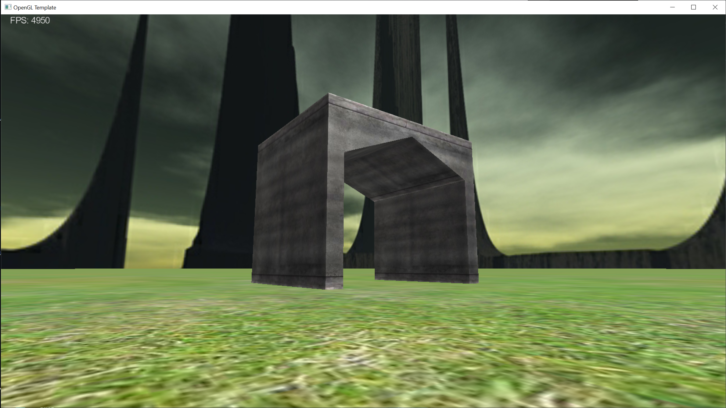

**Task 7:**

The obj file is included within submission folder.